A Title of the Article Should Be Specific and Effective (not more than 15 words)
First Author’s Name^{1*}, Second Author’s Name², Third Author’s Name³
¹Job Title, Department, Faculty, University, Country, ORCID
²Job Title, Department, Faculty, University, Country, ORCID
³Job Title, Department, Faculty, University, Country, ORCID

*Corresponding author:

Article History | ABSTRACT (200-250 words)  Introduction:  Methods:  Results:  Conclusion:  ABSTRAK (200-250 words)  Pendahuluan:  Metode:  Hasil:  Simpulan:
Received:
Revised:
Accepted:
Published online:
DOI: | Keywords:
 | Kata kunci:

INTRODUCTION / PENDAHULUAN
The Journal of Entrepreneurship Perspectives’ major goal is to become an important and respected publication in the field of entrepreneurship perspectives on a national and global scale. The Journal of Entrepreneurship Perspectives will publish original research articles, case reports, review articles, methodology, and other scientific articles. This journal covers entrepreneurial perspective , business performance in MSME’s, entrepreneurship development, entrepreneurial management, creative-preneurship, family business, entrepreneurship education socio-preneurship, digital-preneurship, techno-preneurship, creative business or economy, and other related fields.
The publication specifically tries to promote multidisciplinary work that addresses practical challenges. The Journal of Entrepreneurship Perspectives fosters research and writing that bridges established fields in the entrepreneurship perspectives. We also publish material that arises from and comments on practice that is informed by these theoretical frameworks. This journal provides a friendly and academically rigorous environment in which new and established academics can communicate ideas and promote debate in the entrepreneurship domain. We welcome submissions from across the world.

METHODS / METODE
The Journal of Entrepreneurship Perspectives is a peer-reviewed journal published by PT Solusi Era Mediatama. This statement clarifies the ethical behavior of all parties involved in the act of posting an article in this journal, including the author, the chief editor, the Editorial Board, the peer-reviewed and the publisher. The criteria or guidelines addressed to authors and reviewers by the Editorial Board are based on the principles of the Publishing Ethics Resource Kit (PERK) from Elsevier. If the work/research involves human subjects, human material, or human intervention, the authors must ensure that it is done in accordance with the Helsinki Declaration and has been approved by an appropriate ethics committee. The authors must provide a statement detailing this, including the full name and institution of the research ethics review board, as well as the approval number. All participants must provide informed consent, which the author must keep.
The Journal of Entrepreneurship Perspectives adheres to the Committee on Publication Ethics' Core Practices (COPE). The publication of an article in this journal is an essential building block in the development of a coherent and respected network of knowledge. It is a direct reflection of the quality of the work of the authors and the institutions that support them. Peer-reviewed articles support and embody the scientific method. It is therefore essential to agree upon standards of expected ethical behavior for all parties involved in the act of publishing: the author, the journal editor, the peer reviewer, the publisher, and the society. PT Solusi Era Mediatama as the publisher of Journal of Entrepreneurship Perspectives takes its duties of guardianship over all stages of publishing exceptionally seriously, and we recognize our ethical and other responsibilities. We are committed to ensuring that advertising, reprint, or additional commercial revenue has no impact or influence on editorial decisions.
The Journal of Entrepreneurship Perspectives Editorial Board respects and promotes diversity, equity, and inclusion by accepting submissions only based on research and scholarly merit and integrity without considering race, ethnicity, nationality, citizenship, gender, religion, or financial means. An editor at any time evaluates manuscripts for their intellectual content without regard to race, gender, sexual orientation, religious belief, ethnic origin, citizenship, or political philosophy of the authors. The editor and any editorial staff must not disclose any information about a submitted manuscript to anyone other than the corresponding author, reviewers, potential reviewers, other editorial advisers, and the publisher, as appropriate.
Unpublished materials disclosed in a submitted manuscript must not be used in an editor's own research without the express written consent of the author. The editor board journal is responsible for deciding which of the articles submitted to the journal should be published. The validation of the work in question and its importance to researchers and readers must always drive such decisions. The editors may be guided by the policies of the journal's editorial board and constrained by such legal requirements as shall then be in force regarding libel, copyright infringement and plagiarism. The editors may confer with other editors or reviewers in making this decision.

RESULTS AND DISCUSSION / HASIL DAN PEMBAHASAN
Results / Hasil
The editor must ensure that each manuscript is initially evaluated by the editor for originality. The editor should organize and use peer review fairly and wisely. Editors should explain their peer review processes in the information for authors and indicate which parts of the journal are peer-reviewed. The editor should use appropriate peer reviewers for papers that are considered for publication by selecting people with sufficient expertise and avoiding those with conflicts of interest. Peer review assists the editor in making editorial decisions and through the editorial communications with the author may also help the author in improving the paper.
Any selected referee who feels unqualified to review the research reported in a manuscript or knows that its prompt review will be impossible should notify the editor and excuse himself from the review process. Any manuscripts received for review must treat as confidential documents. They must not be shown to or discussed with others except as authorized by the editor. Reviews should conduct objectively. Personal criticism of the author is inappropriate. Referees should express their views clearly with supporting arguments. Reviewers should identify relevant published work that has not been cited by the authors. Any statement that an observation, derivation, or argument reported should accompany by the appropriate citation. A reviewer should also call to the editor's attention any substantial similarity or overlap between the manuscript under consideration and any other published paper of which they have personal knowledge.
Privileged information or ideas obtained through peer review must be kept confidential and not used for personal advantage. Reviewers should not consider manuscripts in which they have conflicts of interest resulting from competitive, collaborative, or other relationships or connections with any of the authors, companies, or institutions connected to the papers. Authors of reports of original research should present an accurate account of the work performed as well as an objective discussion of its significance. Underlying data should be represented accurately in the paper. A paper should contain sufficient detail and references to permit others to replicate the work. Fraudulent or knowingly inaccurate statements constitute unethical behavior and are unacceptable.
Table 1. Title
Variable | Indicator | Remark
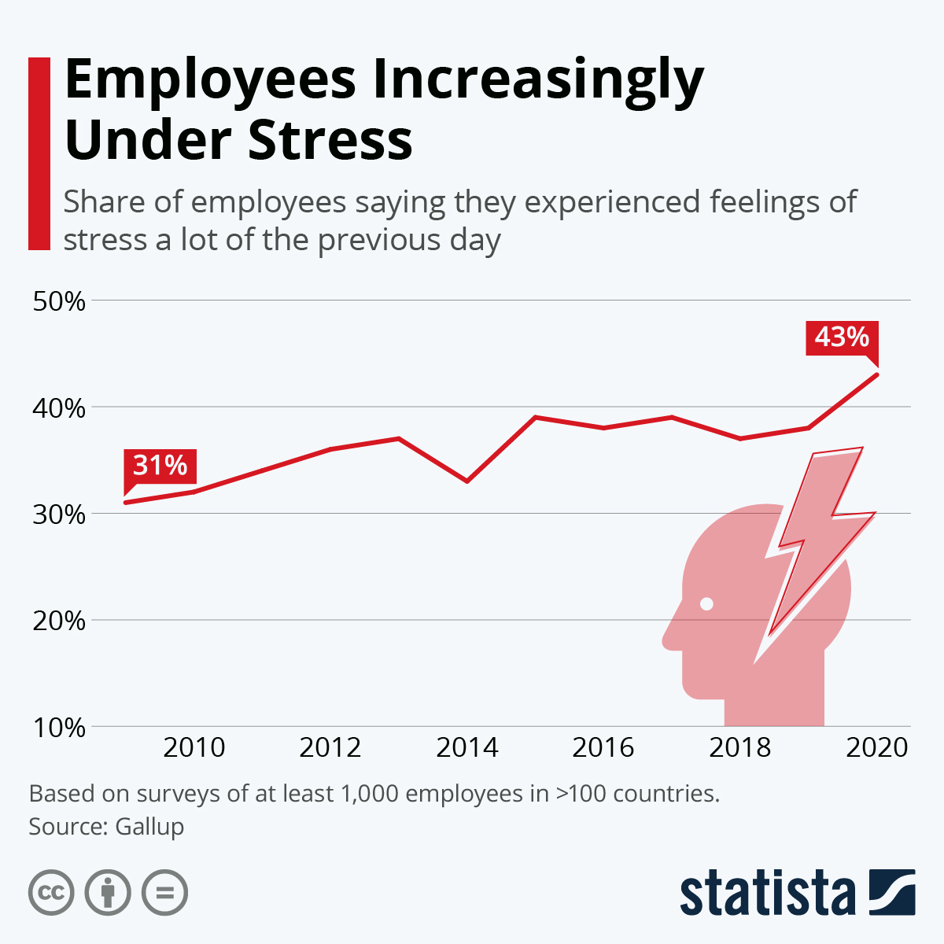

Figure 1. Employee Increasingly Under Stress
Source: https://www.statista.com/chart/26363/share-employees-feeling-stress-timeline/

Discussion / Pembahasan
Authors are asked to provide the raw data in connection with a paper for editorial review and should be prepared to provide public access to such data (consistent with the ALPSP-STM Statement on Data and Databases), if practicable, and should, in any event, be prepared to retain such data for a reasonable time after publication. The authors should ensure that they have written entirely original actions and if the authors have used the works, or words of others that this has appropriately cited or quoted. An author should not, in general, publish manuscripts describing essentially the same research in more than one journal or primary publication. Submitting the same paper concurrently to more than one journal constitutes unethical publishing behavior and is unacceptable.
Proper acknowledgment of the work of others must always be given. Authors should cite publications that have been influential in determining the nature of the reported work. Authorship should be limited to those who have made a significant contribution to the conception, design, execution, or interpretation of the reported study. All those who have made significant contributions should be listed as co-authors. Where there are others who have participated in certain substantive aspects of the research project, they should be acknowledged or listed as contributors. The corresponding author should ensure that all appropriate co-authors and no inappropriate co-authors are included on the paper and that all co-authors have seen and approved the final version of the article and have agreed to its submission for publication.
When an author discovers a significant error or inaccuracy in his/her own published work, it is the author’s obligation to promptly notify the journal editor or publisher and cooperate with the editor to retract or correct the paper. The self-citation refers to when an author refers to the previous work written by him/her alone or in co-authorship and cites it. Self-cites are used to compare current results of the research with earlier findings when continuing to study the same subject. It seems that the only reasonable solution for the issues of self-plagiarism, research integrity, and originality is to limit the number of self-citations.
This journal Self-Citation Restriction Policy regulates that the self-citation level should not exceed 10% for an author, 20% for co-authors together, and 15% for Journal of Entrepreneurship Perspectives. If the reference checker (software) finds that this rule has been broken, then the manuscript will be automatically rejected by the Desk Editor without further review. All work in the manuscript should be avoided of any plagiarism, falsification, fabrications, or omission of significant material. Authors are expected to explicitly cite others' work and ideas, even if the work or ideas are not quoted verbatim or paraphrased. This standard applies whether the previous work is published, unpublished, or electronically available. Failure to properly cite the work of others may constitute plagiarism. Plagiarism in all its forms constitutes unethical publishing behaviour and is unacceptable.

CONCLUSION / SIMPULAN
The Journal of Entrepreneurship Perspectives applies a minimum standard of similarity score of the manuscript under 20%. If the manuscript performs above 20%, the article should be revised or rejected. The Journal of Entrepreneurship Perspectives applies a screening for plagiarism using Turnitin. The Journal of Entrepreneurship Perspectives takes its responsibility to maintain the integrity and completeness of the scholarly record of our content for all end users very seriously. Changes to articles after they have been published online may only be made under the circumstances outlined below. The Journal of Entrepreneurship Perspectives places great importance on the authority of articles after they have been published and our policy is based on best practice in the academic publishing community.
An Erratum is a statement by the authors of the original paper that briefly describes any correction(s) resulting from errors or omissions. Any effects on the conclusions of the paper should be noted. The corrected article is not removed from the online journal but notice of erratum is given. The Erratum is made freely available to all readers and is linked to the corrected article. A Retraction is a notice that the paper should not be regarded as part of the scientific literature. Retractions are issued if there is clear evidence that the findings are unreliable, this can be because of misconduct or honest error; if the findings have previously been published elsewhere without proper referencing, permission, or justification; if the work is plagiarized; or if the work reports unethical research.

Theoretical Implications / Implikasi Teoritis
To protect the integrity of the record, the retracted article is not removed from the online journal, but notice of retraction is given, is made freely available to all readers, and is linked to the retracted article. Retractions can be published by the authors when they have discovered substantial scientific errors; in other cases, the Editors or Publisher may conclude that retraction is appropriate. In all cases, the retraction indicates the reason for the action and who is responsible for the decision. If a retraction is made without the unanimous agreement of the authors, that is also noted. In rare and extreme cases involving legal infringement, the Publisher may redact or remove an article. Bibliographic information about the article will be retained to ensure the integrity of the scientific record.

Practical Implications / Implikasi Praktis
A Publisher's Note notifies readers that an article has been corrected after publication. It is issued by the Publisher and is used in cases where typographical or production errors (which are the fault of the Publisher) affect the integrity of the article metadata (such as title, author list or byline) or will significantly impact the readers' ability to comprehend the article. The original article is removed and replaced with a corrected version. Publisher's Notes are freely available to all readers. Minor errors that do not affect the integrity of the metadata or a reader's ability to understand an article and that do not involve a scientific error or omission will be corrected at the discretion of the Publisher.

REFERENCES / REFERENSI (use the latest APA style)
Akinwale, O. E., & George, O. J. (2020). Work environment and job satisfaction among nurses in government tertiary hospitals in Nigeria. Rajagiri Management Journal, 14(1), 71–92. https://doi.org/10.1108/RAMJ-01-2020-0002
Alrawashdeh, H. M., Al-Tammemi, A. B., Alzawahreh, M. K., Al-Tamimi, A., Elkholy, M., Al Sarireh, F., Abusamak, M., Elehamer, N. M. K., Malkawi, A., Al-Dolat, W., Abu-Ismail, L., Al-Far, A., & Ghoul, I. (2021). Occupational burnout and job satisfaction among physicians in times of COVID-19 crisis: a convergent parallel mixed-method study. BMC Public Health, 21(1), 811. https://doi.org/10.1186/s12889-021-10897-4
Aman-Ullah, A., Ibrahim, H., Aziz, A., & Mehmood, W. (2022). Impact of workplace safety on employee retention using sequential mediation: evidence from the health-care sector. RAUSP Management Journal, 57(2), 182–198. https://doi.org/10.1108/RAUSP-02-2021-0043
Bartoll, X., & Ramos, R. (2020). Working hour mismatch, job quality, and mental well-being across the EU28: a multilevel approach. International Archives of Occupational and Environmental Health, 93(6), 733–745. https://doi.org/10.1007/s00420-020-01529-2
Chung, H. (2020). Gender, Flexibility Stigma and the Perceived Negative Consequences of Flexible Working in the UK. Social Indicators Research, 151(2), 521–545. https://doi.org/10.1007/s11205-018-2036-7
Chung, H., & van der Horst, M. (2020). Flexible Working and Unpaid Overtime in the UK: The Role of Gender, Parental and Occupational Status. Social Indicators Research, 151(2), 495–520. https://doi.org/10.1007/s11205-018-2028-7
Chung, H., & van der Lippe, T. (2020). Flexible Working, Work–Life Balance, and Gender Equality: Introduction. Social Indicators Research, 151(2), 365–381. https://doi.org/10.1007/s11205-018-2025-x
Giménez-Espert, M. D. C., Prado-Gascó, V., & Soto-Rubio, A. (2020). Psychosocial Risks, Work Engagement, and Job Satisfaction of Nurses During COVID-19 Pandemic. Frontiers in Public Health, 8(566896), 1–10. https://doi.org/10.3389/fpubh.2020.566896
Irawanto, D. W., Novianti, K. R., & Roz, K. (2021). Work from Home: Measuring Satisfaction between Work–Life Balance and Work Stress during the COVID-19 Pandemic in Indonesia. Economies, 9(3:96), 1–13. https://doi.org/10.3390/economies9030096
Kim, J. (2020). Workplace Flexibility and Parent–Child Interactions Among Working Parents in the U.S. Social Indicators Research, 151(2), 427–469. https://doi.org/10.1007/s11205-018-2032-y
Kim, S. J., & Chung, E. K. (2019). The effect of organizational justice as perceived by occupational drivers on traffic accidents: Mediating effects of job satisfaction. Journal of Safety Research, 68, 27–32. https://doi.org/https://doi.org/10.1016/j.jsr.2018.11.001
Lott, Y. (2020). Does Flexibility Help Employees Switch Off from Work? Flexible Working-Time Arrangements and Cognitive Work-to-Home Spillover for Women and Men in Germany. Social Indicators Research, 151(2), 471–494. https://doi.org/10.1007/s11205-018-2031-z
Obrenovic, B., Jianguo, D., Khudaykulov, A., & Khan, M. A. S. (2020). Work-Family Conflict Impact on Psychological Safety and Psychological Well-Being: A Job Performance Model. Frontiers in Psychology, 11(475), 1–18. https://doi.org/10.3389/fpsyg.2020.00475
Paais, M., & Pattiruhu, J. R. (2020). Effect of Motivation, Leadership, and Organizational Culture on Satisfaction and Employee Performance. Journal of Asian Finance, Economics and Business, 7(8), 577–588. https://doi.org/10.13106/JAFEB.2020.VOL7.NO8.577
Pancasila, I., Haryono, S., & Sulistyo, B. A. (2020). Effects of Work Motivation and Leadership toward Work Satisfaction and Employee Performance: Evidence from Indonesia. Journal of Asian Finance, Economics and Business, 7(6), 387–397. https://doi.org/10.13106/jafeb.2020.vol7.no6.387
Roberts, J. A., & David, M. E. (2020). Boss phubbing, trust, job satisfaction and employee performance. Personality and Individual Differences, 155, 109702. https://doi.org/https://doi.org/10.1016/j.paid.2019.109702
Rodríguez Rodríguez, E. (2022). La “soberanía sobre el tiempo”. Unilateralidad e imposición en la distribución del tiempo de trabajo frente a conciliación corresponsable. Cuadernos de Relaciones Laborales, 40(1), 37–55. https://doi.org/10.5209/crla.77642
Saffar, N. A. G. A.-. (2020). The effect of total quality management practices on employee performance: The moderating role of knowledge sharing. Management Science Letters, 10(1), 77–90. https://doi.org/10.5267/j.msl.2019.8.014
Said, R. M., & El-Shafei, D. A. (2021). Occupational stress, job satisfaction, and intent to leave: nurses working on front lines during COVID-19 pandemic in Zagazig City, Egypt. Environmental Science and Pollution Research, 28(7), 8791–8801. https://doi.org/10.1007/s11356-020-11235-8
Thorsen, S. V., Flyvholm, M.-A., Pedersen, J., Bültmann, U., Andersen, L. L., & Bjorner, J. B. (2021). Associations between physical and psychosocial work environment factors and sickness absence incidence depend on the lengths of the sickness absence episodes: a prospective study of 27 678 Danish employees. Occupational and Environmental Medicine, 78(1), 46–53. https://doi.org/10.1136/oemed-2020-106554
van der Lippe, T., & Lippényi, Z. (2020). Beyond Formal Access: Organizational Context, Working From Home, and Work–Family Conflict of Men and Women in European Workplaces. Social Indicators Research, 151(2), 383–402. https://doi.org/10.1007/s11205-018-1993-1
Wibowo, S., Christian, M., Sunarno, S., & Yuniarto, Y. (2022). Determinants of Stress Recognition and Job Satisfaction in Hospitals For Health Professionals in Indonesia. Journal of Industrial Engineering and Management Systems, 15(1), 26–34. https://doi.org/10.30813/jiems.v15i1.3601
Wibowo, S., Sunarno, S., Gasjirin, J., Christian, M., & Indriyarti, E. R. (2023). Psychological and Organizational Factors Impacting Job Satisfaction during the COVID-19 Pandemic: A Study on Similar Exposure Groups in Indonesia. Acta Medica Philippina, Online(March), 1–11. https://doi.org/10.47895/amp.vi0.3688
Wolor, C. W., Solikhah, S., Fidhyallah, N. F., & Lestari, D. P. (2020). Effectiveness of E-Training, E-Leadership, and Work Life Balance on Employee Performance during COVID-19. Journal of Asian Finance, Economics and Business, 7(10), 443–450. https://doi.org/10.13106/jafeb.2020.vol7.no10.443
Zoghbi-Manrique-de-Lara, P., & Sharifiatashgah, M. (2020). An affective events model of the influence of the physical work environment on interpersonal citizenship behavior. In Journal of Work and Organizational Psychology (Vol. 36, Issue 1, pp. 27–37). Colegio Oficial de Psicólogos de Madrid. https://doi.org/10.5093/jwop2019a27

